Registration Page:

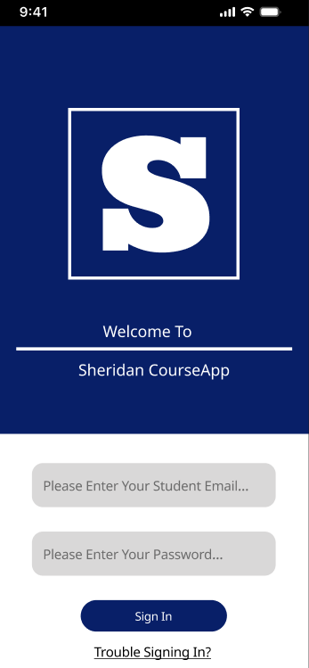

Course List Page:

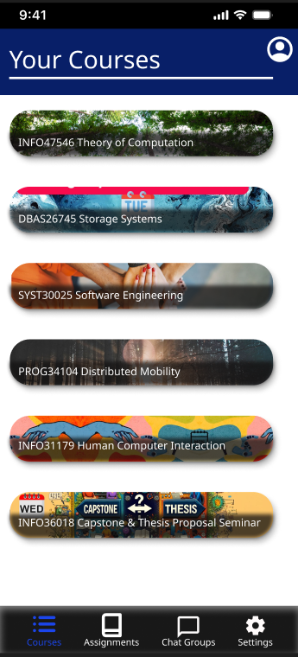

Course Announcement Page:

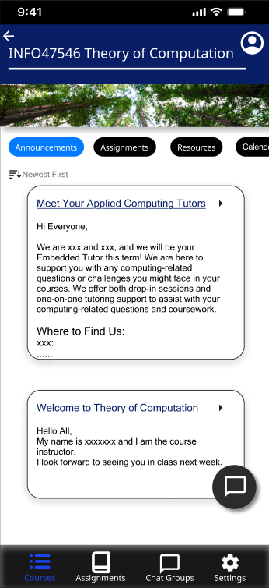

Course Assignment Page:

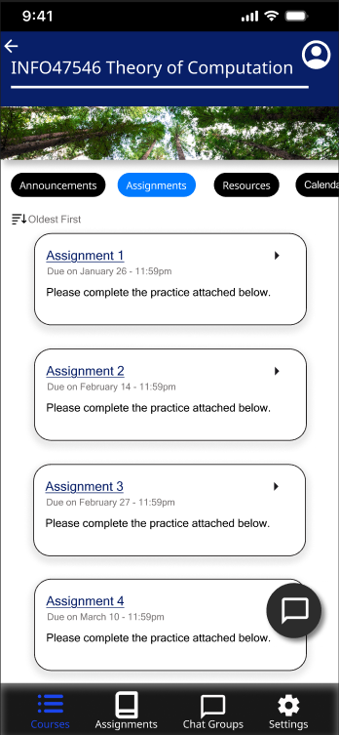

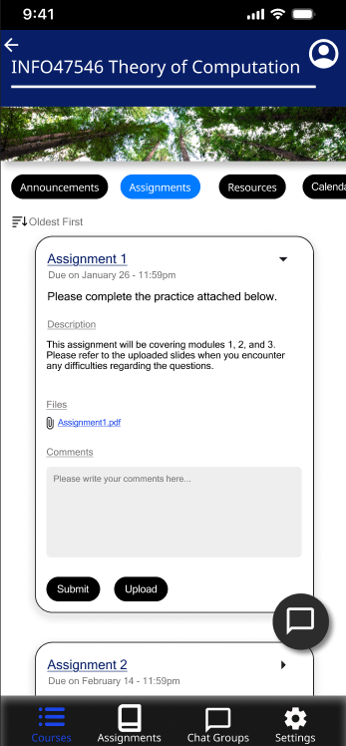

Course Chat Groups Page:

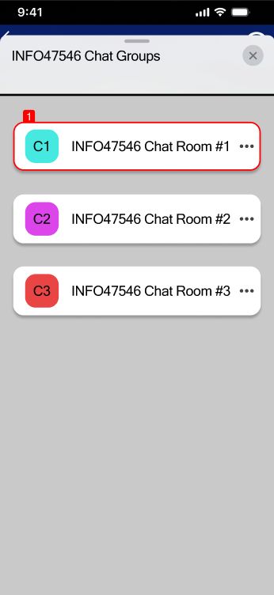

Chat Room Page:

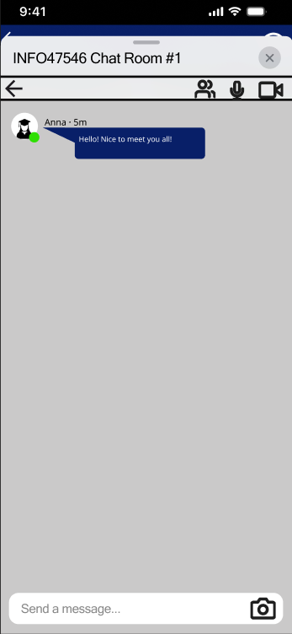

All Chat Groups Page:

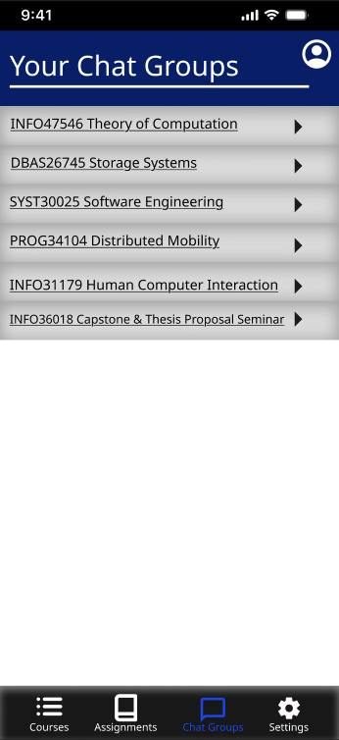

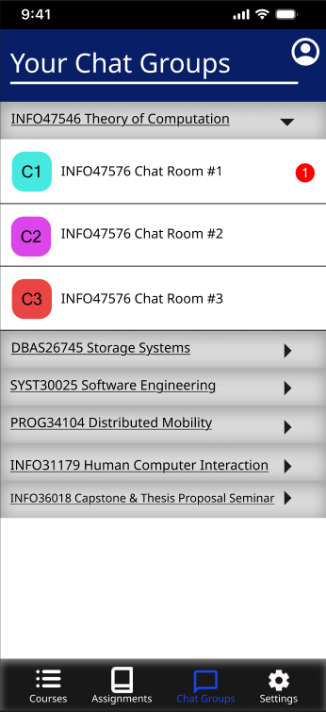

Design Link: <https://www.figma.com/design/TunjPOAgv83PzceR6w7huD/HCI-Assignment-2?node-id=0-1&t=Pw0uFlttO8NfnWMn-1>

Prototype Link: <https://www.figma.com/proto/TunjPOAgv83PzceR6w7huD/HCI-Assignment-2?node-id=0-1&t=Pw0uFlttO8NfnWMn-1>